Challenge: To expand the Valve creation and placement function

Development environment: Unity2018.3.12

Programing language: C#

Unity Scene: Assets/Scenes/Main

Base Project:

* CFlatProject.zip

Reference

* ControlValve(DiaphramType).mov

Specification confirmation:

1. Entity creation/placement  
    By dragging and dropping each entity icon into the view, the target entity will be created at the drop position.  
     
   Please confirm that the Control Valve (Diaphragm Type) can be created by dragging and dropping the Diaphragm CV icon into the view.
2. Entity Geometry and Dimension

It is possible to change the entity's dimension by changing the parameters in the CSV file. Changes in the CSV file are reflected when the entity is placed by drag and drop.  
Change any parameter in StreamingAssets/VTP/Instruments/All/ControlValve.csv. Save the file then place new ControlValve into the view. Confirm how the changes in the dimension of the newly placed entity were reflected.

Task description:

Fix the project so that Control Valve(Actuator Type) can be created and placed in the view.

1. Entity icon  
    Drag and drop the ActuatorCV icon below to create a ControlValve (ActuatorType).

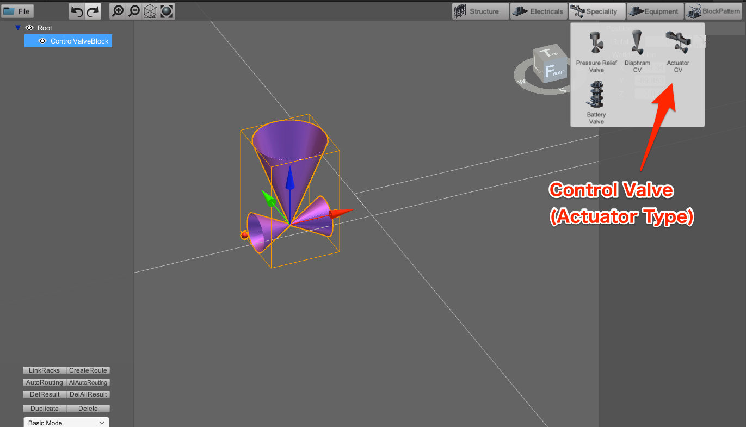

1. Entity Geometry and Dimension

Create the geometry of the Control Valve (Actuator Type) as shown in the image below.

Moreover, when the sizes of A to D are changed in the CSV file, make sure that the changes are reflected in the view when the entity is created.

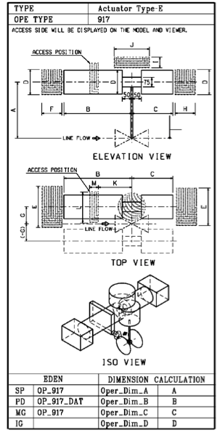

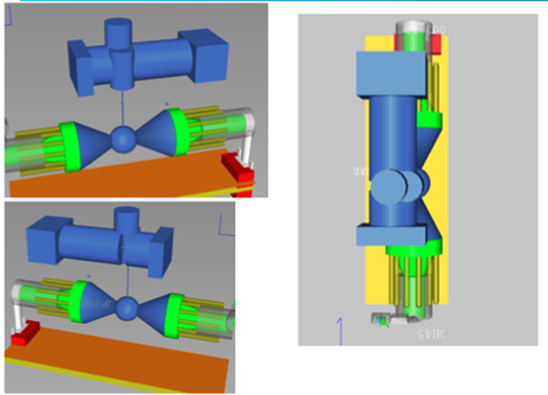  
         For reference, the entity should look like the blue entity shown below.

1. Tips  
   Implement using Control Valve (Diaphragm Type) as a reference.

Related files are as follows.

●      ControlValveEquipmentIcon.cs (Class for Drag&Drop)

●      ControlValve.cs (equivalent to Model in MVC Architecture)

●      ControlValveBodyCreator.cs (Class to create GameObject)

●  ControlValveBodyImpl.cs (Class for Prefabs)

●      ControlValveTableImporter.cs (Class to get Model Parameter from CSV)

●  StreamingAssets/VTP/Instruments/All/ControlValve.csv

●      Prefabs/Models/Components/ControlValve.prefab

The following files must also be created in reference to the above.

●      ActuatorControlValveEquipmentIcon.cs

●      ActuatorControlValve.cs

●      ActuatorControlValveBodyCreator.cs

●      ActuatorControlValveBodyImpl.cs

●      ActuatorControlValveTableImporter.cs

●  StreamingAssets/VTP/Instruments/All/ActuatorControlValve.csv

●      Prefabs/Models/Components/ActuatorControlValve.prefab

There are classes which need to be changed as well such as:

●      EntityType.cs

●      BodyPrefabAccessor.cs

 Submission:

1. Development code set

All the necessary files to execute Main.unity on a UnityEditor, which include Main.unity, the prefabs, and the codes you have developed etc.

1. A video  
    Using ControlValve(DiaphramType).mov as a reference, submit a video of placing the Actuator Control Valve along with your output .

The End.